Christ Church Book of Remembrance

In conjunction with the Garden of Remembrance, we have a Book of Remembrance which sits on the North altar. Names of those whose cremated remains are buried in the Garden of Remembrance will automatically be written in the Book of Remembrance. [You will still need to complete the form overleaf, to ensure we have all the details correct.]

Names will be written in the month of the person’s death and the book will be updated by the calligrapher at least once a year.

If you wish to have the name of a loved one or friend who worshipped at Christ Church included, please complete the form attached and send it to the Parish Office.

There is no charge, but a contribution towards the cost of the calligraphy and administration would be very welcome.
Suggested donation £15.

We prefer payment by BACS to Eaton Christ Church PCC
Please email office@eatonchurches.org.uk for the details
Please use BOOK OF REM as a reference.

Alternatively, please make cheques payable to:
Eaton Christ Church PCC
and send to
Parishes Office, 41 Church Lane, Norwich NR4 6NW

Christ Church Book of Remembrance

I would like the following name entered in
the Book of Remembrance in Christ Church, Eaton.

Details of Deceased
Name (in capitals)
Date of birth
Date of death
Your connection with the person named
Your Details
Name

Address
Phone no. / Mobile
Email
Signed

Dated

Please detach and return the completed form to:
The Parish Administrator
The Parishes’ Office
41 Church Lane
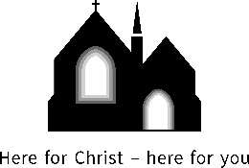
Norwich NR4 6NW

